**Baseline Survey for Digital Profile of Local Governments**

The Constitution of Nepal promulgated on September 20, 2015 provides for the state restructuring with three levels of the Government – federal, provincial and local – and assigned the devolution of power and authority closer to the citizens. Accordingly, restructuring process established Governments at three levels: one Federal Government 7 Provincial Governments and 753 Local Level (Metropolitan city – 6, Sub-metropolitan City – 11, Municipality – 276 and Rural Municipality – 460). In the restructuring process, 753 local levels have been physically demarcated through 3,915 VDCs (before there were 3,915 Village Development Committees – VDCs – with 9 wards for each VDC) and its wards. Local Government Operations Act (LGOA) 2017 has clearly provisioned that Local Governments should develop and implement periodic, annual, strategic, sectoral, mid and long-term development plans. It is also provisioned that local government has to update its database before annual planning and budgeting each year. These provisions have made mandatory an updatable database for local governments.

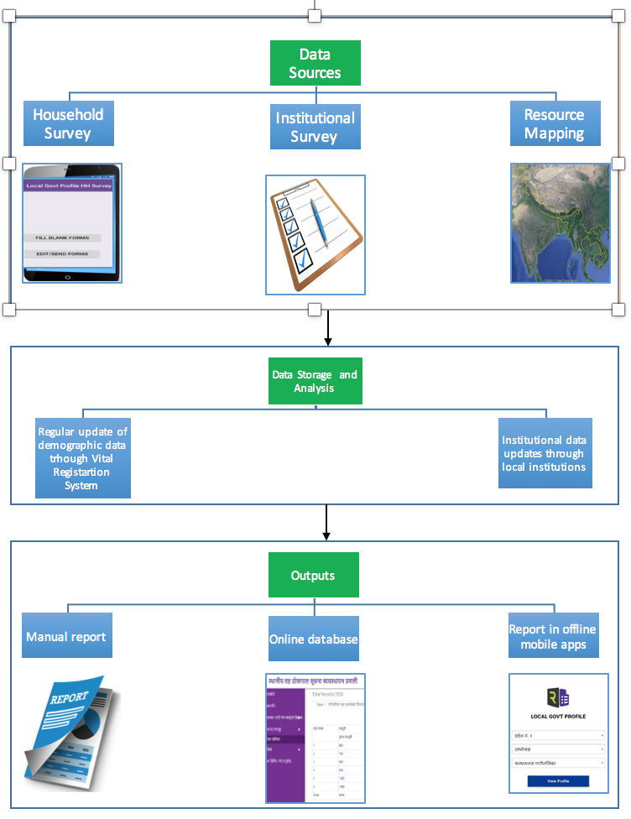

***Figure 1: Digital Profile Information Management System***

For establishing uniformity in local database management system, the federal government has approved *Rural/Urban Profile Preparation Procedure 2019* for profile preparation at the local levels. Most of the LG have developed paper-based profile based on National Census of 2011. However, this process is insufficient to generate robust fresh data, while, at the same time, the policy provisions emphasizes real time updatable data management systems *(LGOA 2017, Article 12, Sub Article 2 B)*.

In this context, a concept of *Digital Profile*, a systematic online database management system, has been introduced in Nepal and its first piloting was carried out by Community Development Program (CDP), a complementary project of LGCDP executed by Ministry of Federal Affair and General Administration (MoFAGA. Subsequently, this piloting process has introduced *Local Government Profile Information Management System* (<https://lgprofile.robustitconcepts.com>) and Robust IT Concepts Pvt. Ltd and Centre for Sustainable Development Studies (CSDS) Pvt. Ltd. have been promoting digital profile through this system.

Key features of this system are:

* Data collected through Android Mobile using the questionnaire provided in *Rural/Urban Profile Preparation Procedure, 2075.*
* Each household is recorded with GPS
* *More than 125 tables are generated automatically*
* The age of each individual increases by one every year.
* Resource Mapping through a participatory way through google earth
* Demographic database can be updated through Vital Registration System (VRS) every day and Institutional data can be updated by local institutions yearly.
* Report can access through Hard copy, Online database, Offline Mobile App
* Resource maps be displayed as interactive map on online.

**Our Contribution in Digital Profiling**

We are imparting our expertise in developing digital profile of local level since our establishment. 689,584 households covering 3,516,432 population were surveyed under this system from 96 local across the country. Out of 96, CSDS has contributed in 13 Local Level covering more than 150 thousands of households. Following is the list of local levels and system links.

1. Madi Municipality, Sankhuwasabha (3216 HHs) <http://madimun.gov.np> and Go to डिजिटल प्रोफाइल
2. Khandbari Municipality, Sankhuwasabha (7441 HHs) <http://khandbarimun.gov.np> and Go to डिजिटल प्रोफाइल
3. Pacharauta Municipality, Bara (7310 HHs) <http://pachrautamun.gov.np> and Go to डिजिटल प्रोफाइल
4. Hanumannagar Kankalini Municipality, Saptari (9871 HHs) <http://hanumannagaryoginimaimun.gov.np/en> and Go to Digital Profile
5. Sukhipur Municipality, Siraha (8587 HHs) <http://sukhipurmun.gov.np> and Go to Digital Profile
6. Dhanauji RM, Dhanusa (4587 HHs) <http://dhanaujimun.gov.np> and Go to डिजिटल प्रोफाइल
7. Faktaglung RM, Taplejung (2711 HHs) <http://phaktanglungmun.gov.np> and Go to डिजिटल प्रोफाइल
8. Dullu Municipality, Dailekh (8986 HHs) <http://dullumun.gov.np> and Go to डिजिटल प्रोफाइल
9. Sidingwa RM, Taplejung (2510 HHs) <http://sidingbamun.gov.np> and Go to डिजिटल प्रोफाइल
10. Chhinnamasta RM, Saptari (5210 HHs) <http://chhinnamastamun.gov.np> and Go to **विधुतीय सुशासन सेवा** and डिजिटल प्रोफाइल
11. Kamala Municipality, Dhanusa (8587 HHs) <http://kamalamun.gov.np> and Go to डिजिटल प्रोफाइल
12. Bishnu Rural Municipality, Sarlahi (3216 HHs) <http://bishnumun.gov.np> and Go to डिजिटल प्रोफाइल
13. Itahari Sub-Metropolitancity, Sunsari (35693 HHs) <http://itaharimun.gov.np> and Go to डिजिटल प्रोफाइल

To see the report in mobile app please go to Play store >Local Govt Profile >Install >Open >Select Province: 1, District: Shankhuwasabha, Local Level: Madi Municipality, for example.

